Arely Gil

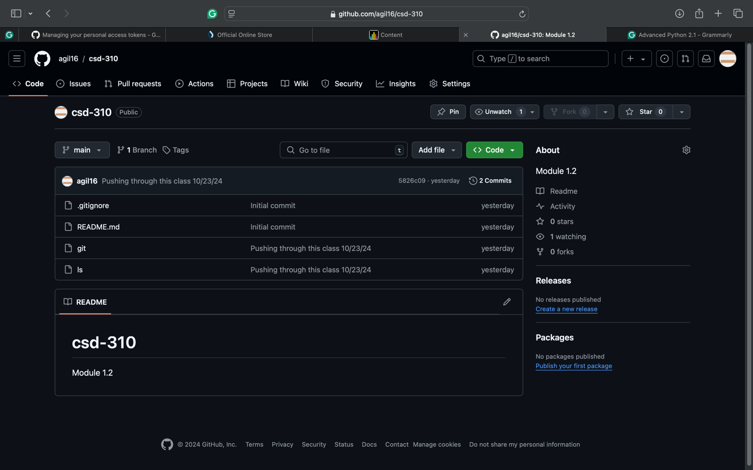

https://github.com/agil16/csd-310.git